**Online Food Ordering System**

**Team 3**

Table of Contents

**Introduction** 3

**UML Diagram** 3

**Process Model** 4

# **Introduction**

The labor rates are increasing progressively year on year thus making it difficult to find employees. The food industry is highly labor intensive and the biggest expense in the food industry is the cost of employing the right kind of people to do the work. One of the ways to reduce this expense is to use modern technology to replace some of the jobs done by human beings and make machines do the work. Here we propose an “Online Food Ordering System” that has been designed for Fast Food restaurant. The system can also be used in any food delivery business. This make things easier the process of food ordering for both the customer and the restaurant.

# **UML Diagram**

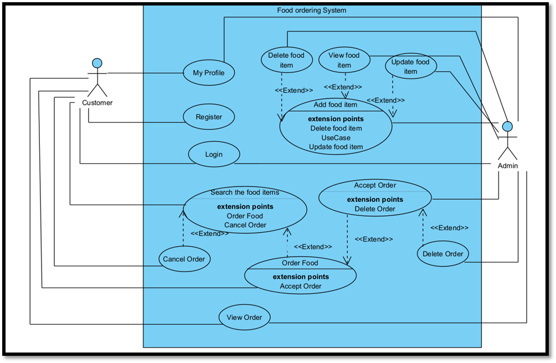

# **Process Model**

|  |  |
| --- | --- |
| **Brief Description** | **Searching for Food and Order** |
| **Basic Flow** | 1. User must have an account.  2. Then search for food. |
| **Alternate Flow** | 1.The system is validating the input information if the data is available or not.  2. If it’s not alert message notified. |
| **Pre-condition** | 1. User must have an account.  2. Network access and preferred App or application. |
| **Post Conditions** | 1.Search food will be displayed successfully.  2.Then ordered successfully. |

|  |  |
| --- | --- |
| **Brief Description** | **Add to cart** |
| **Basic Flow** | 1.User must have an account after that customer has to login through account and add to cart feature is available.  2.User must select food item or food package for add to cart. |
| **Alternate Flow** | 1.User can access through guest account for add to cart option. |
| **Pre-condition** | 1.User must be registered to an account for add to cart option. |
| **Post Conditions** | 1.The food must be added to add to cart option. |

|  |  |
| --- | --- |
| **Brief Description** | **Cancel Order** |
| **Basic Flow** | 1.User must have an account for cancel food order.  2.User must select food or food package to cancel order. |
| **Alternate Flow** | 1. User can access through guest account for cancel food order option. |
| **Pre-condition** | 1.User must be registered to the account for cancel order and more features. |
| **Post Conditions** | 1.The food order must be canceled. |